**Description:**

Amazon Elastic Compute Cloud (Amazon EC2) provides scalable computing

capacity in the Amazon Web Services (AWS) cloud. Using Amazon EC2

eliminates your need to invest in hardware up front so you can develop and

deploy applications faster. You can use Amazon EC2 to launch as many or as

few virtual servers as you need, configure security and networking, and manage

storage. Amazon EC2 enables you to scale up or down to handle changes in

requirements or spikes in popularity, reducing your need to forecast traffic.

**Problem Statement:**

Company ABC wants to move their product to AWS. They have the following

things set up right now:

1. MySQL DB

2. Website (PHP)

The company wants high availability on this product, therefore wants Auto

Scaling to be enabled on this website.

**Steps To Solve:**

1. Launch an EC2 Instance

2. Enable Auto Scaling on these instances (minimum 2)

3. Create an RDS Instance

4. Create Database & Table in RDS instance:

a. Database name: intel

b. Table name: data

c. Database password: intel123

5. Change hostname in website

6. Allow traffic from EC2 to RDS instance

7. Allow all-traffic to EC2 instance

Create EC2 ubuntu instance.

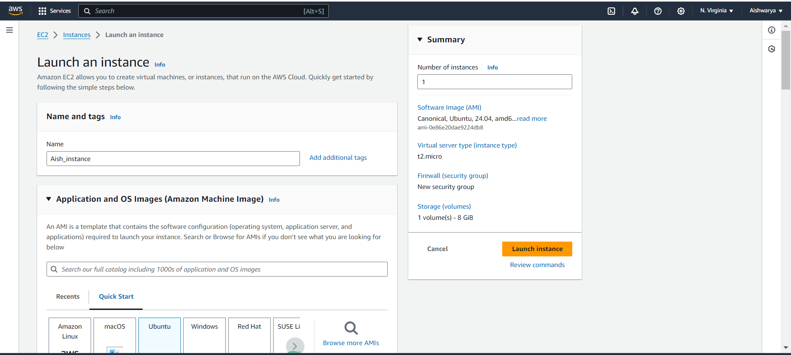

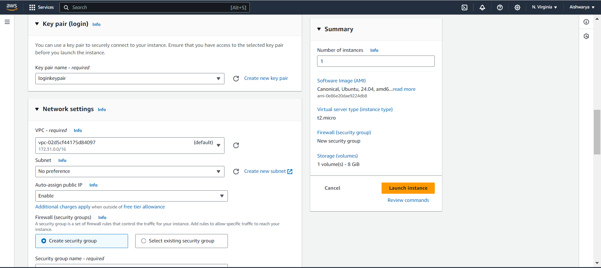

Create SG ssh http and MYSQL

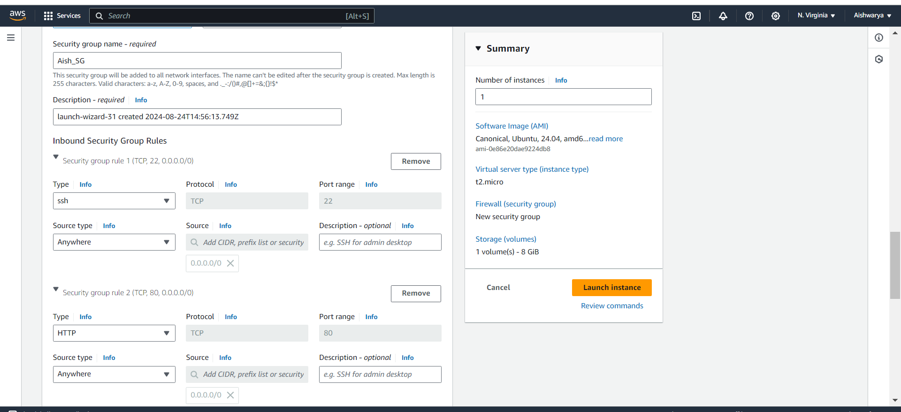

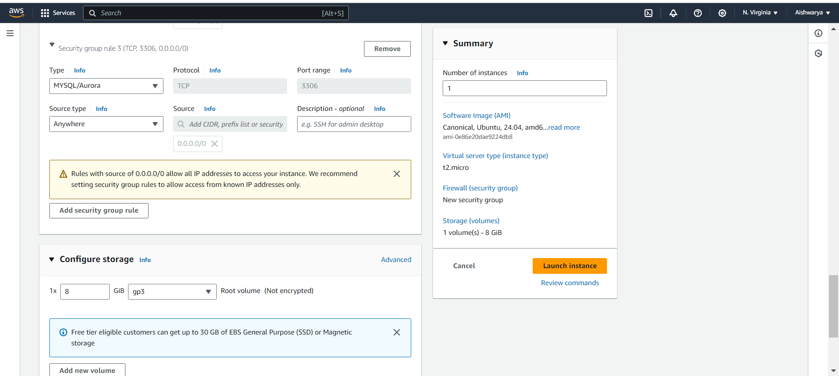

Connect to instance and install apache2

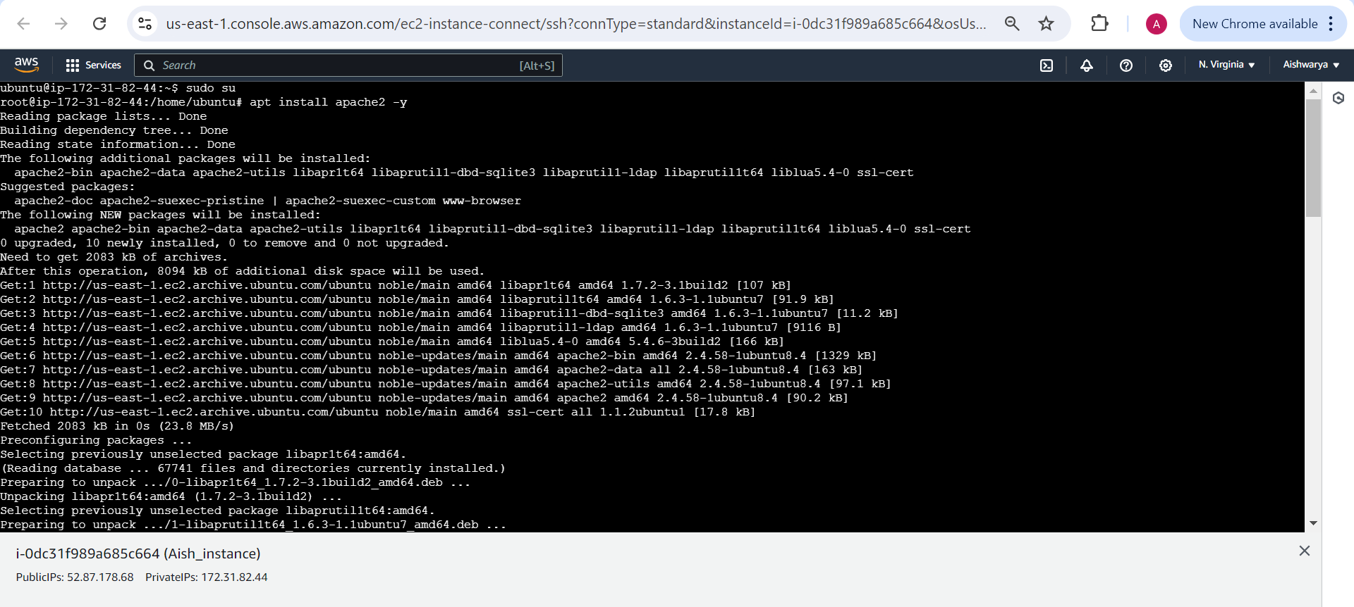

Check apache2 installed correctly

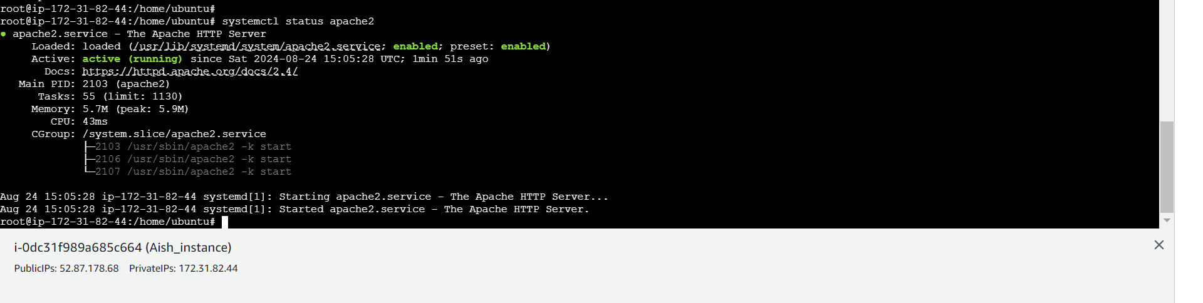

Add index.php

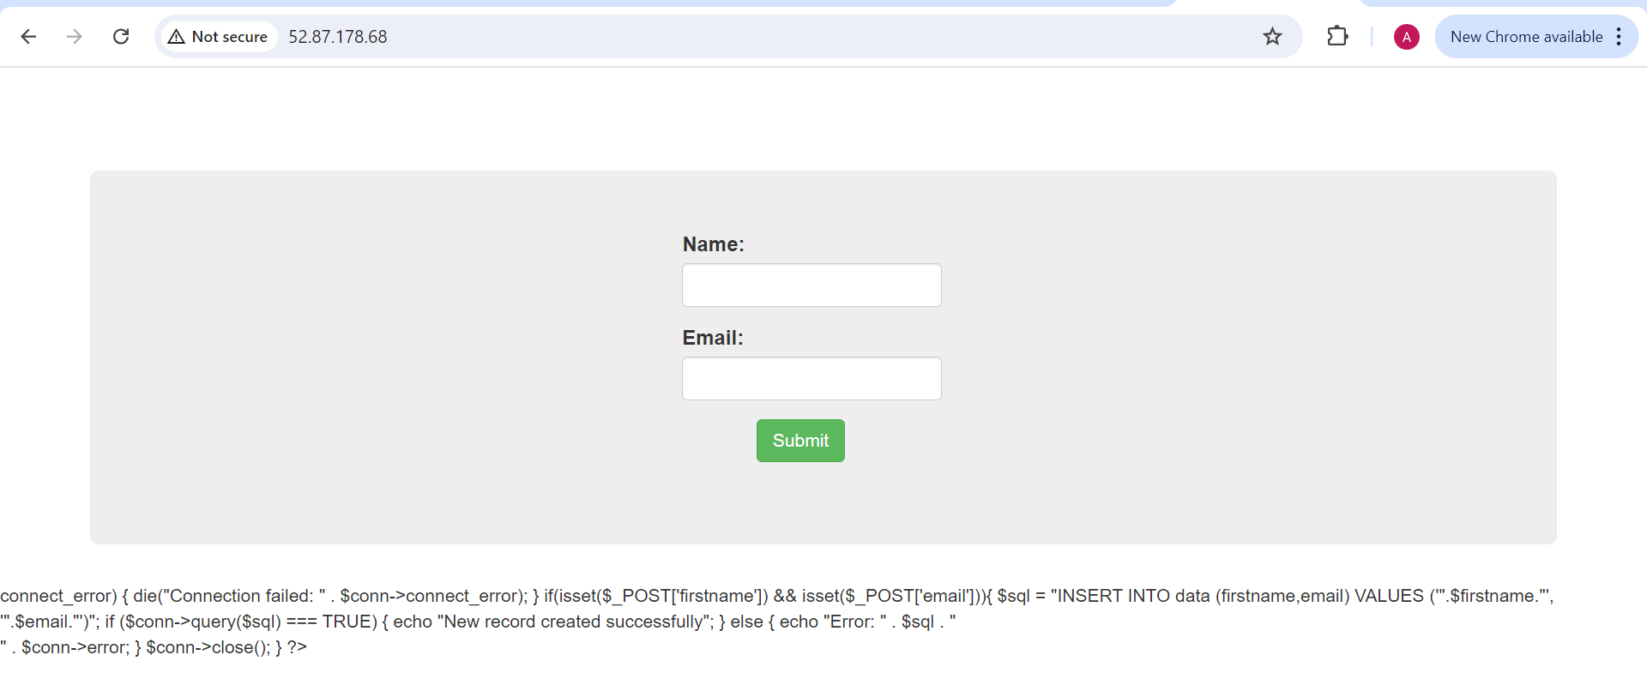

Create Php repository to install php

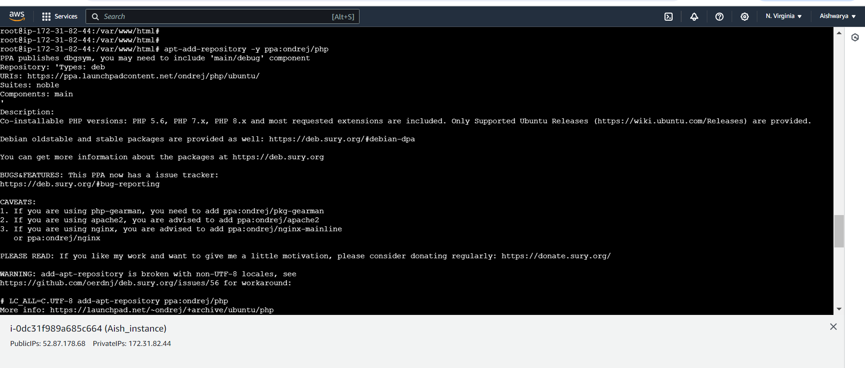

Now, Install php5.6, MySQL-client and php5.6-mysqli

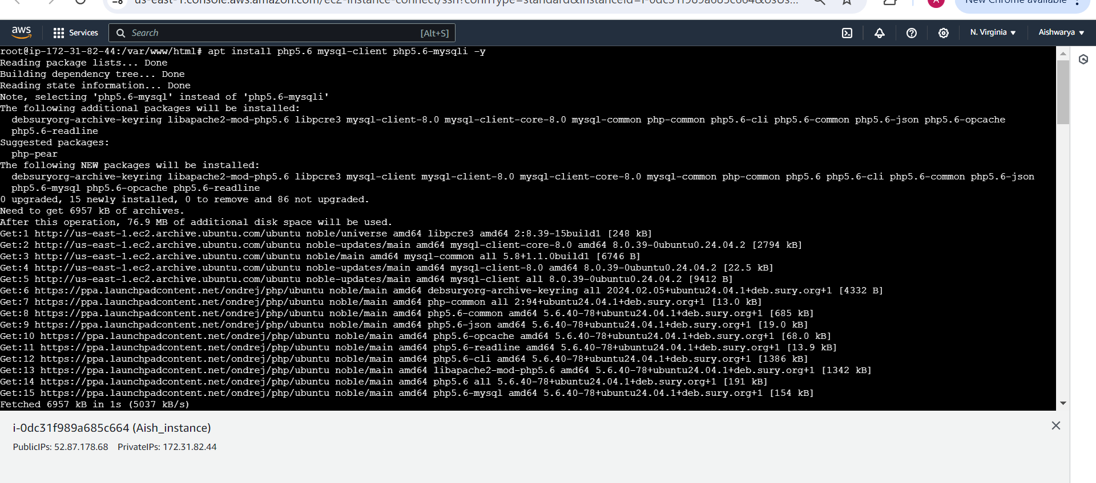

Now php error gone

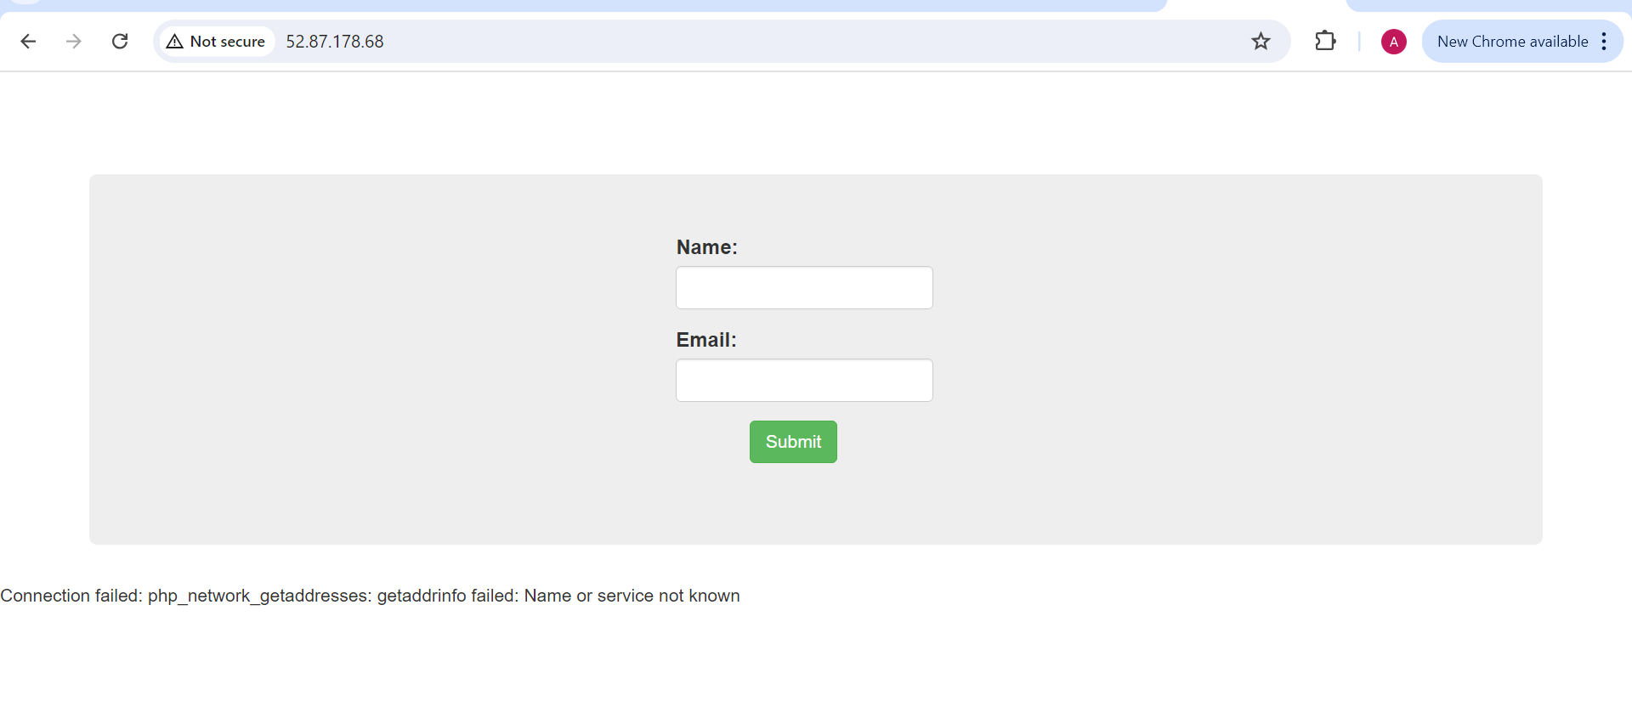

Now create MySQL database

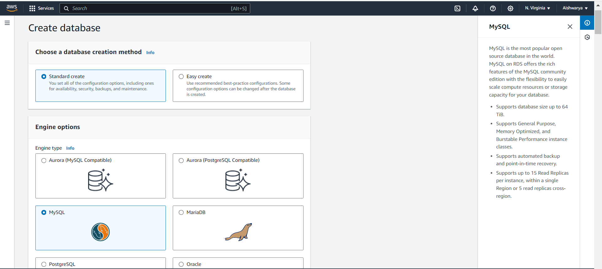

Select free tier

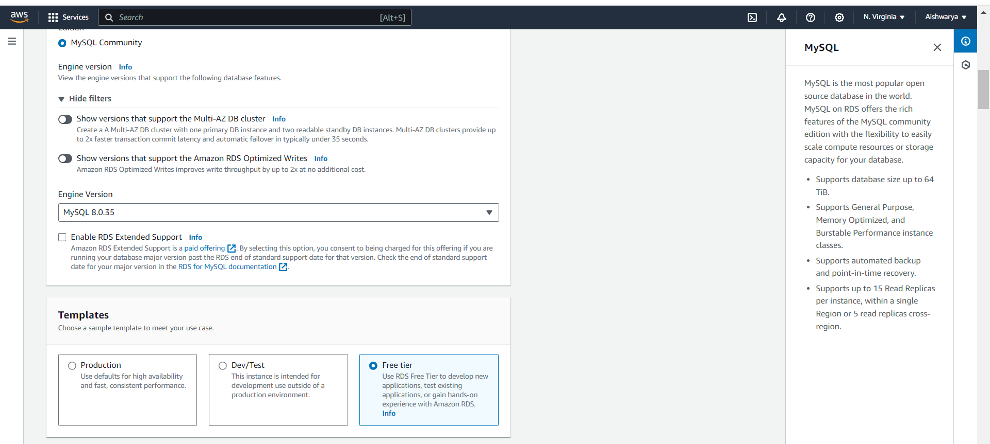

Put username as intel and password as intel123

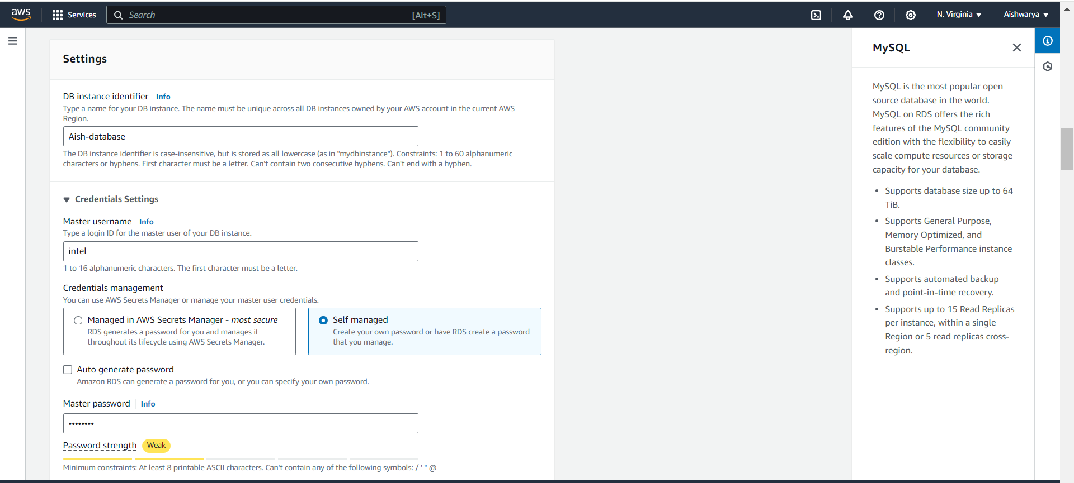

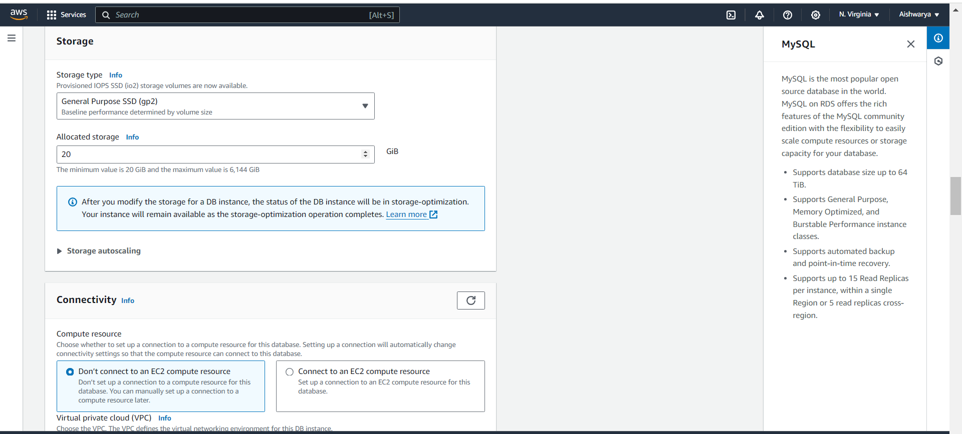

Select security group which we created

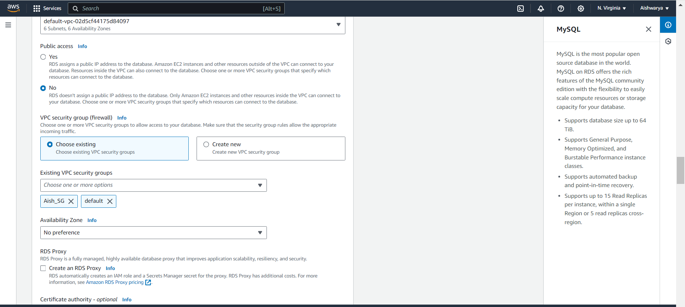

Put database name as intel

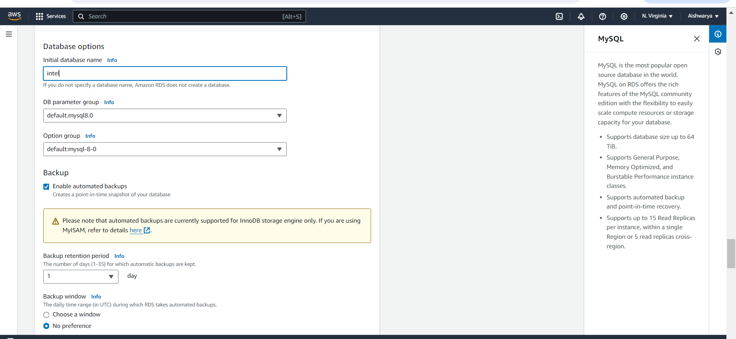

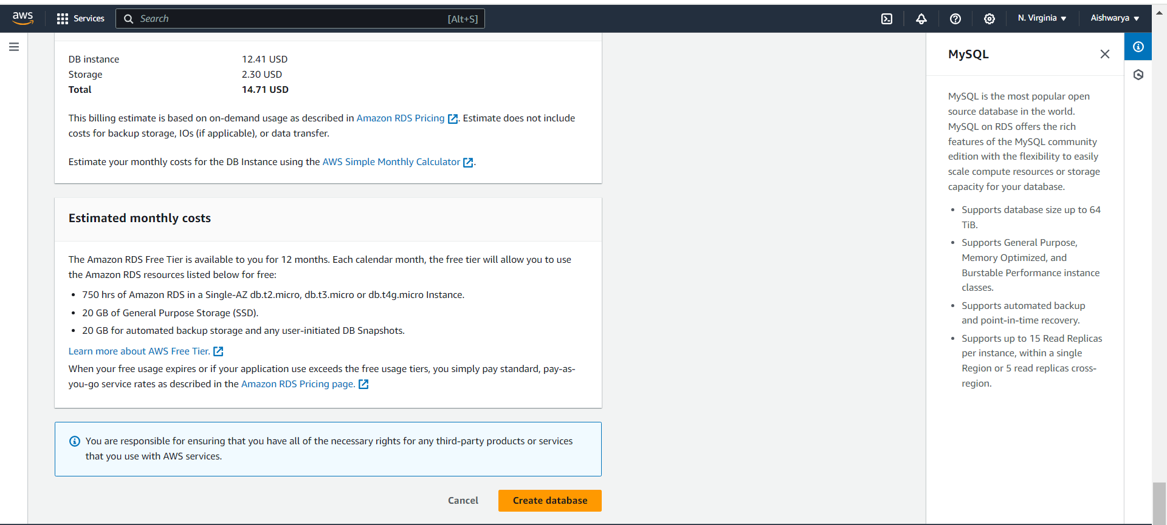

Security group 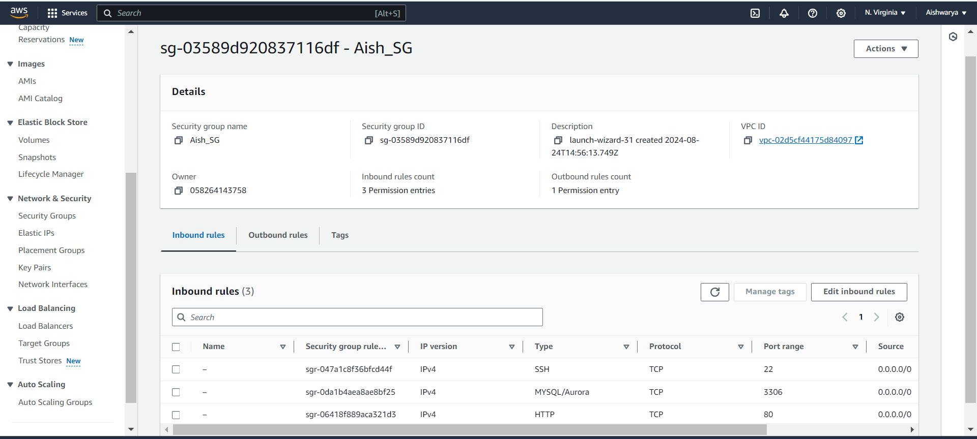

Now database is available

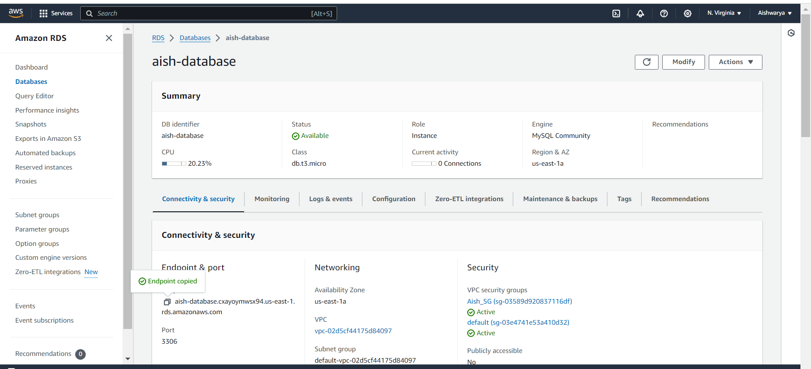

Change endpoint in server name in index.php file and connect to database

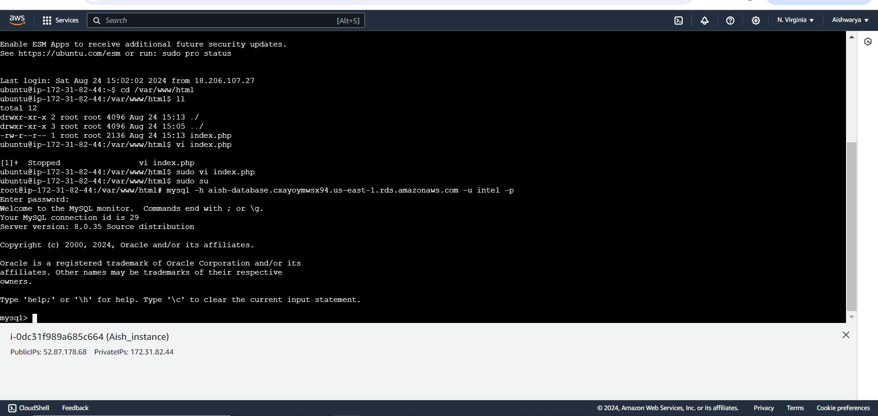

Now error will gone

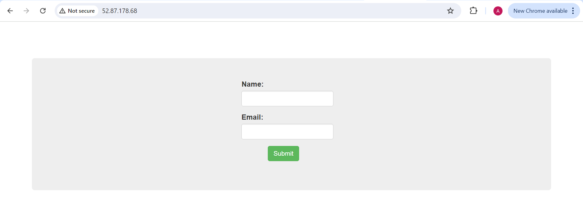

Show database;

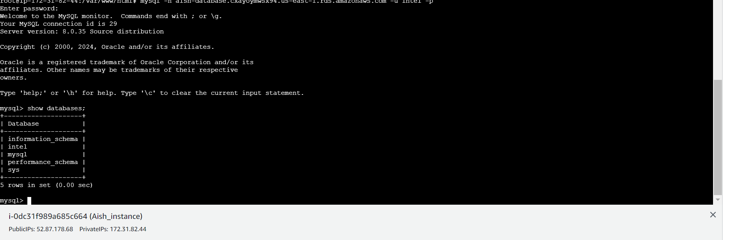

Use intel database which we created and Create table name data

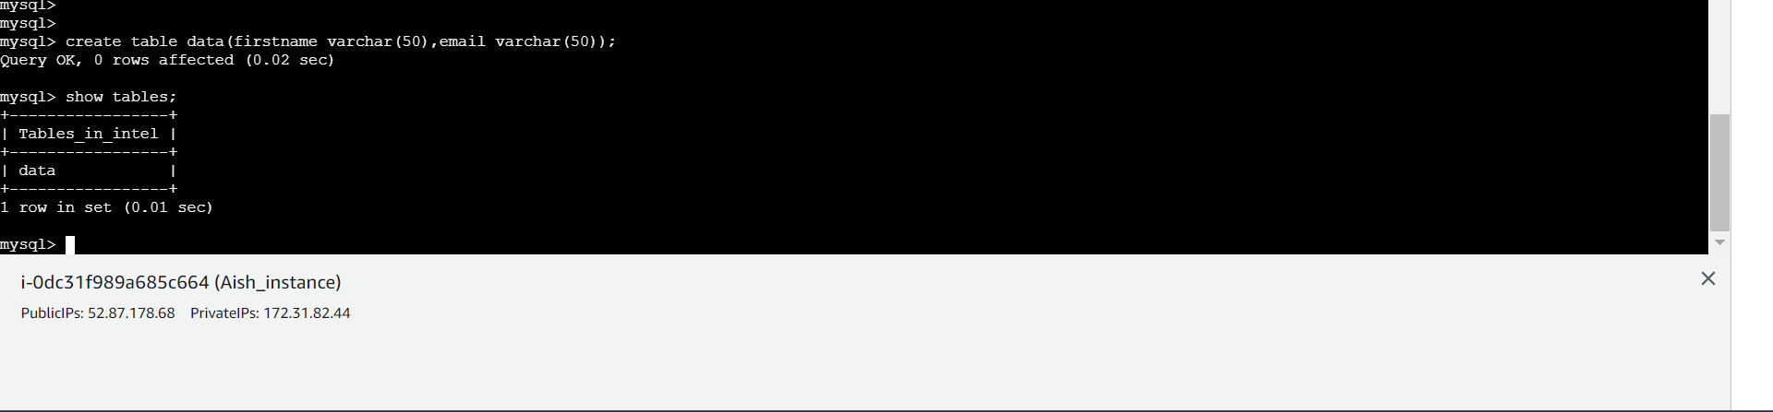

Insert manually

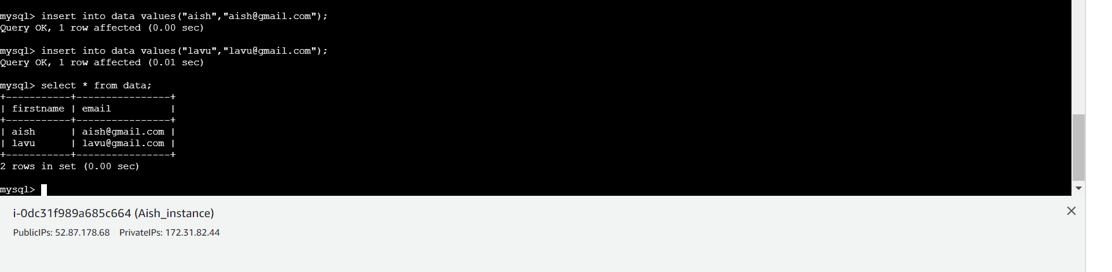

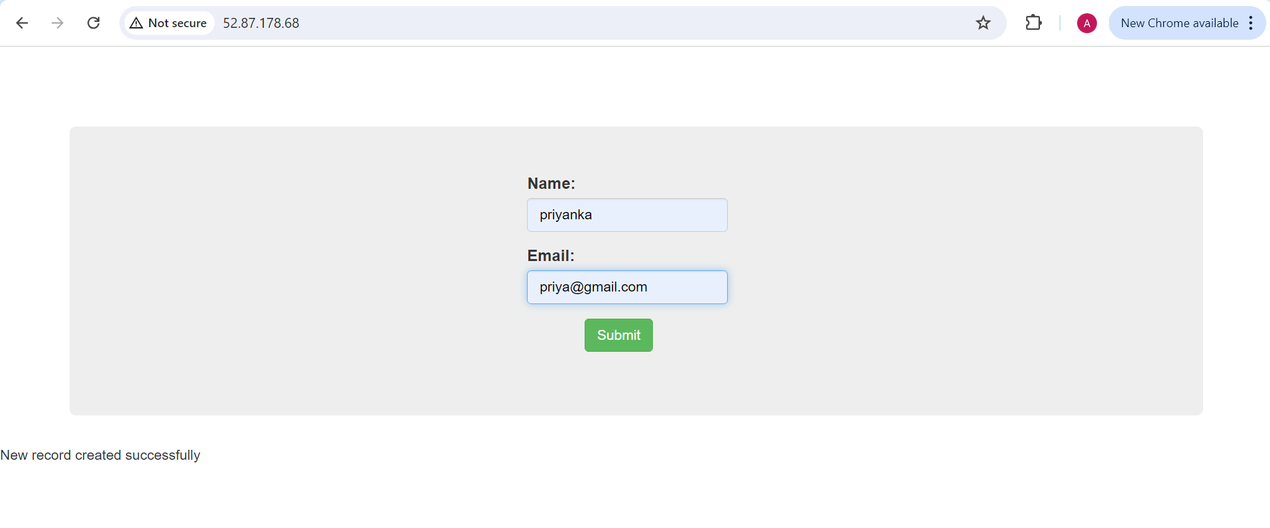

Data inserted successfully

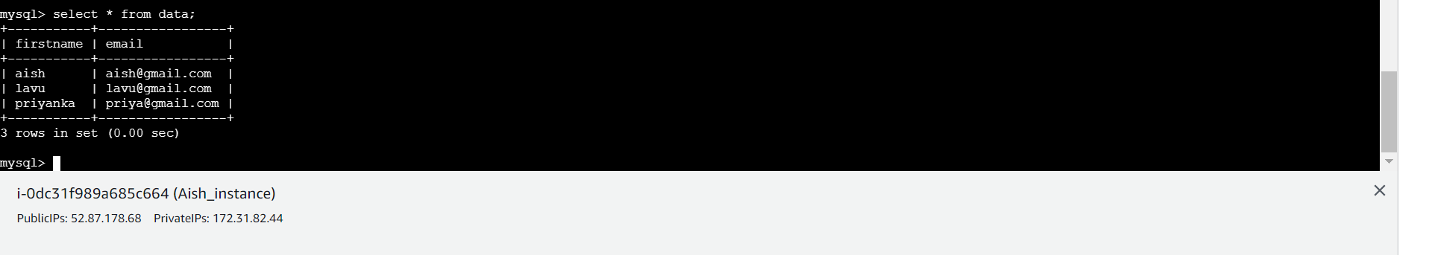

Now create Auto scaling group for this create Lauch Template

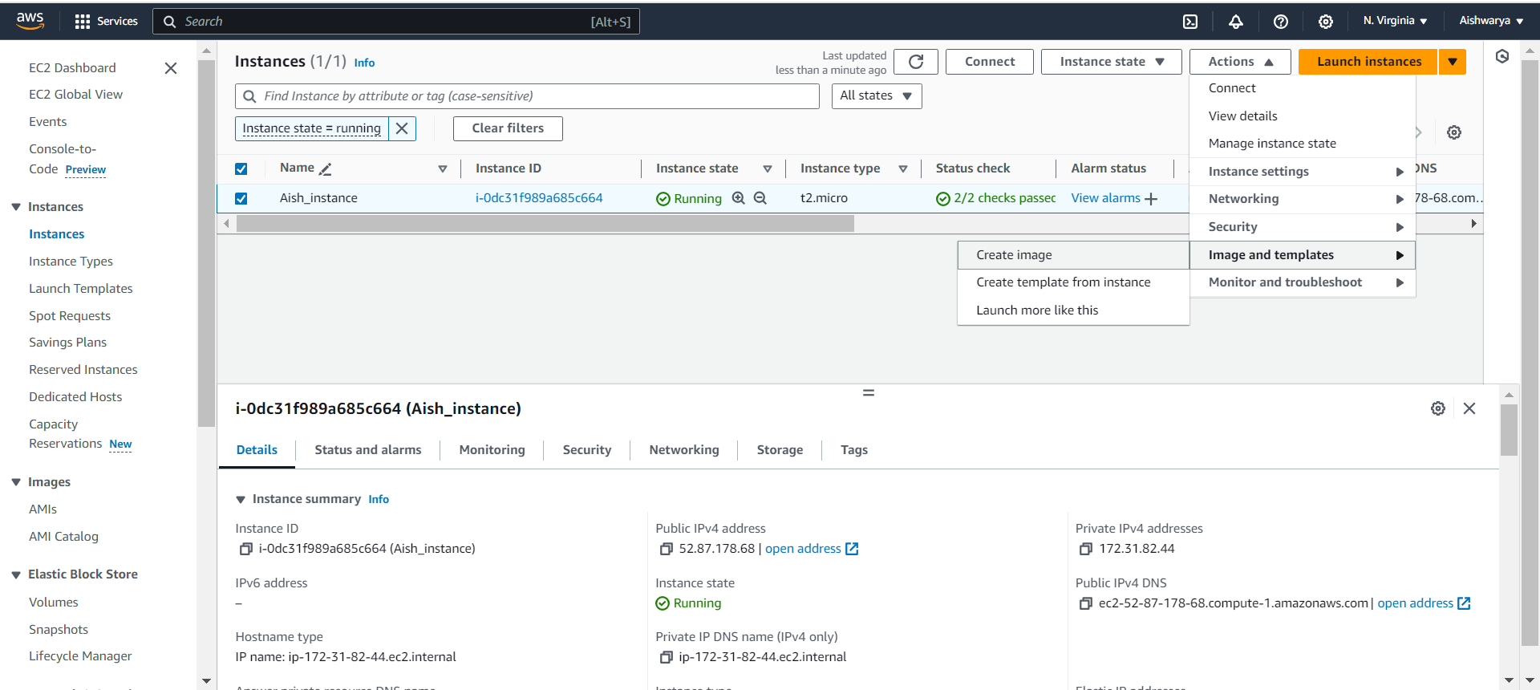

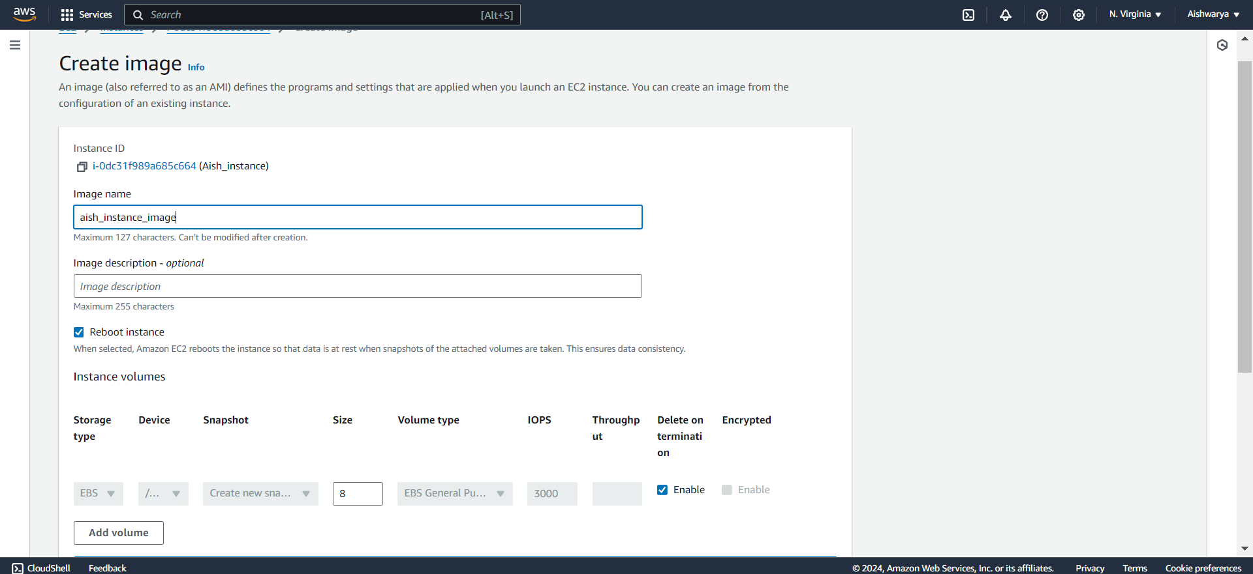

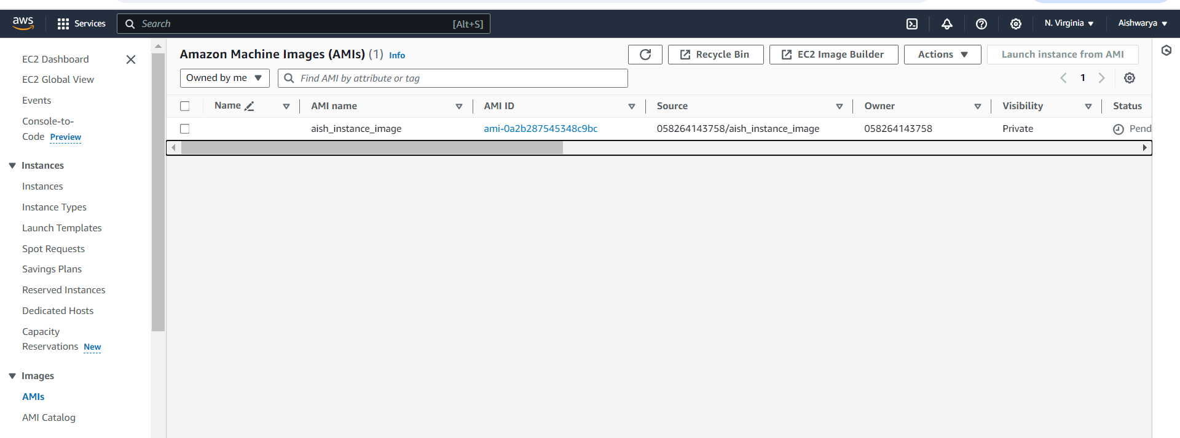

Create lauch template

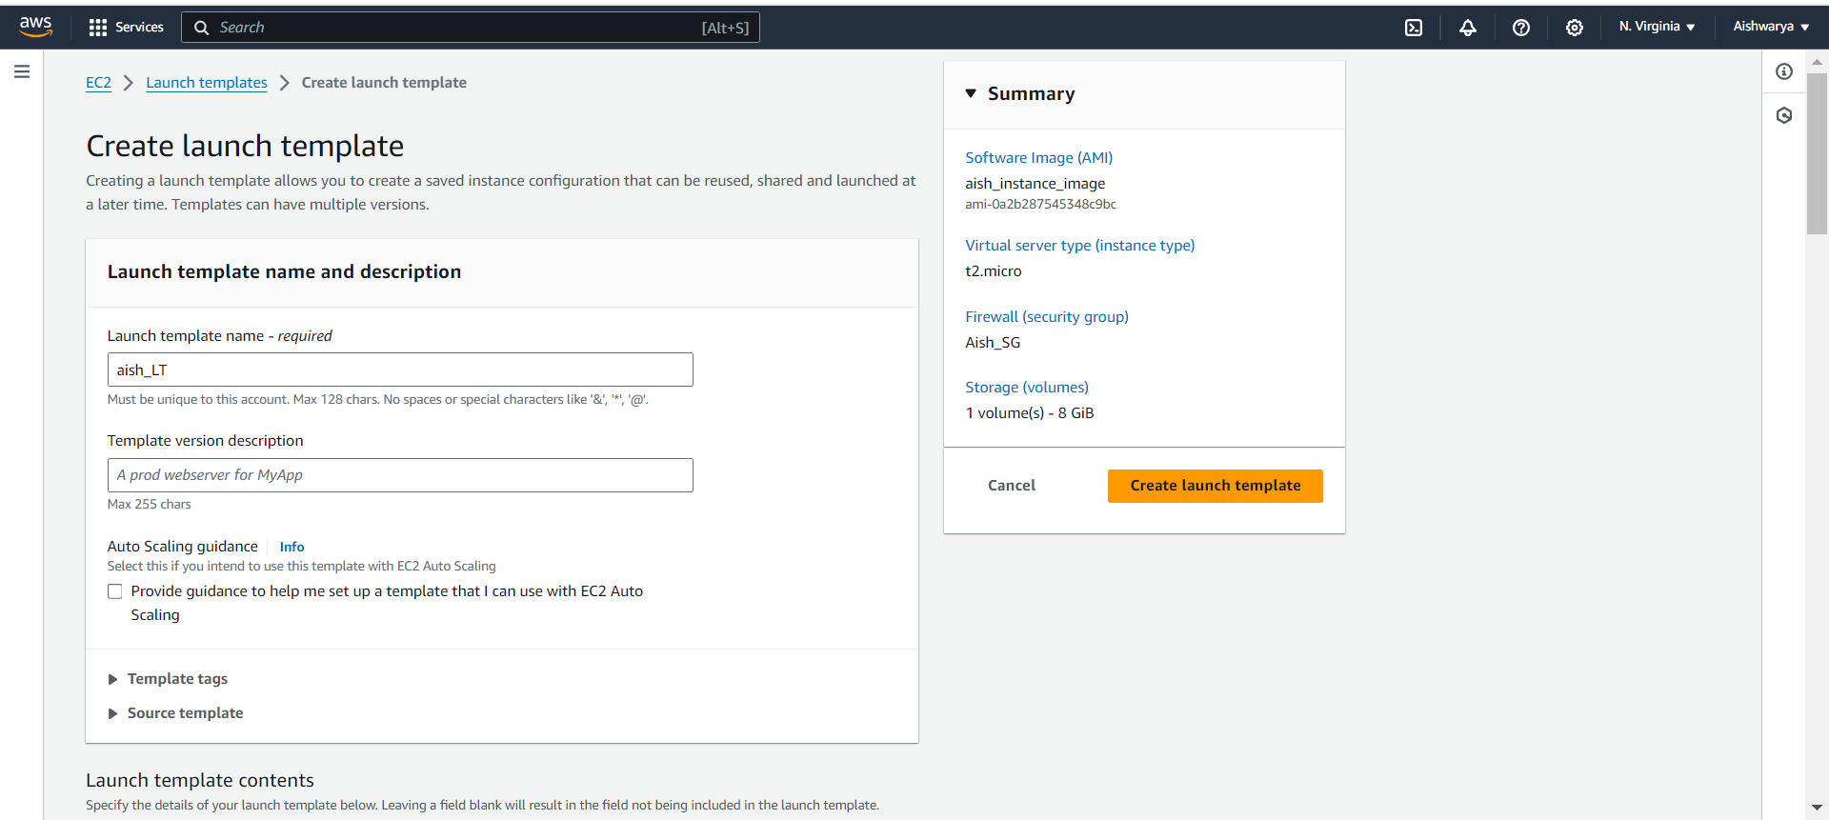

Select AMI which we created

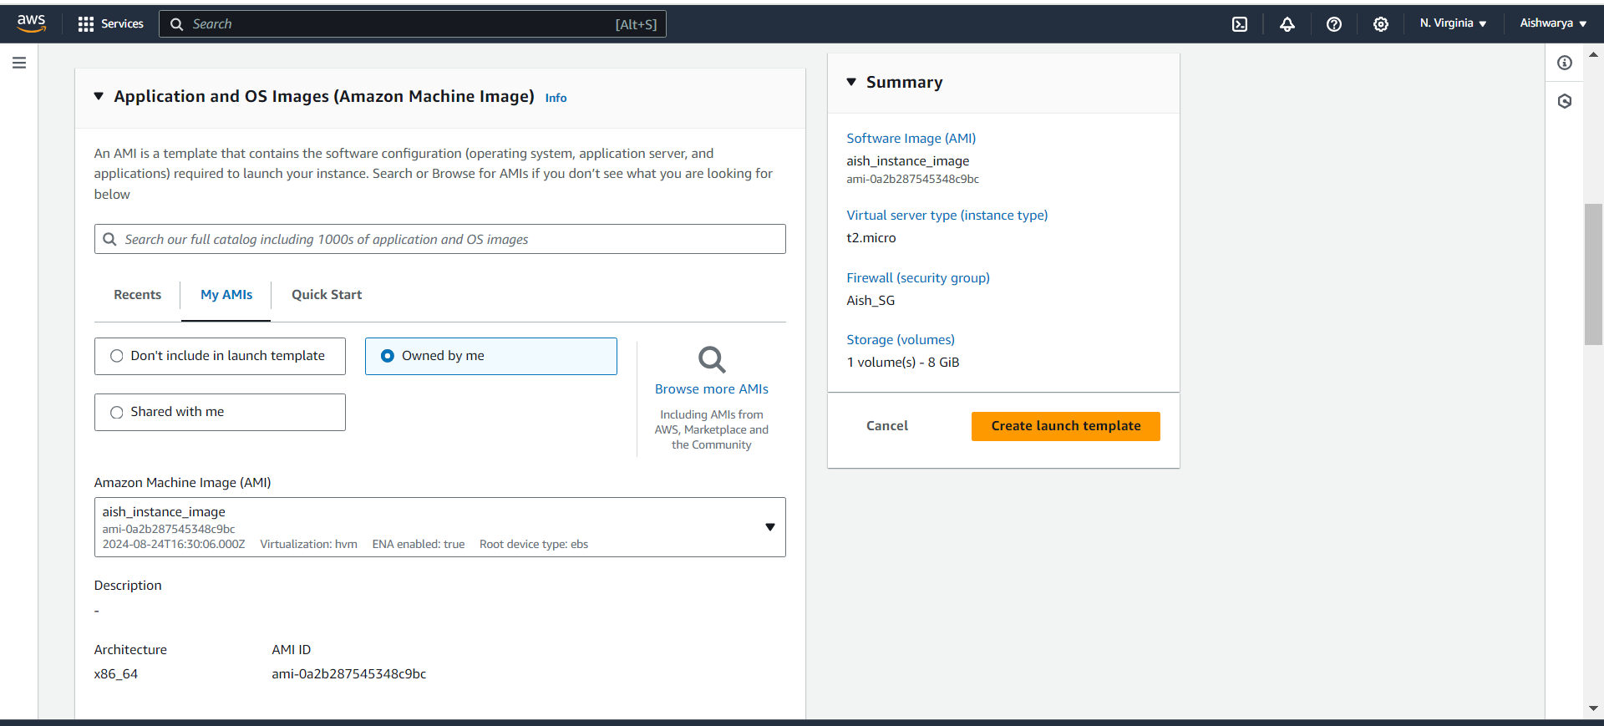

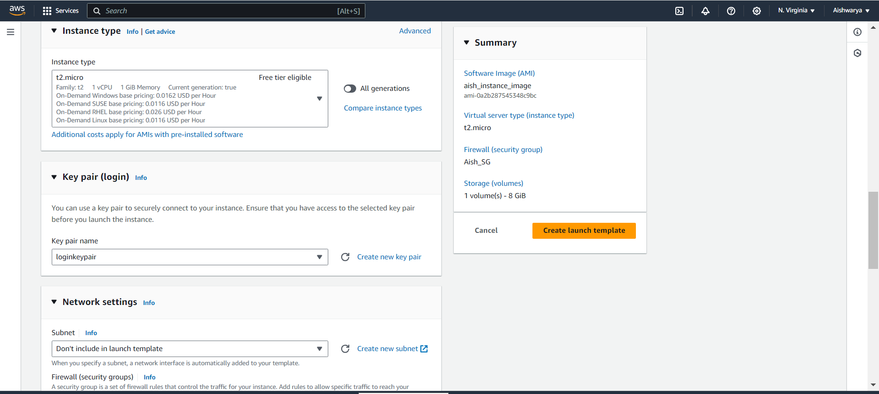

Choose security group

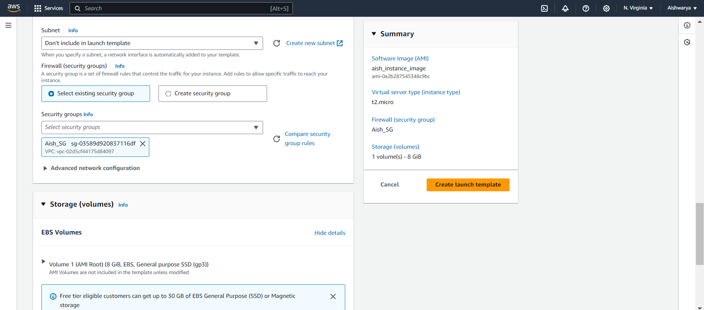

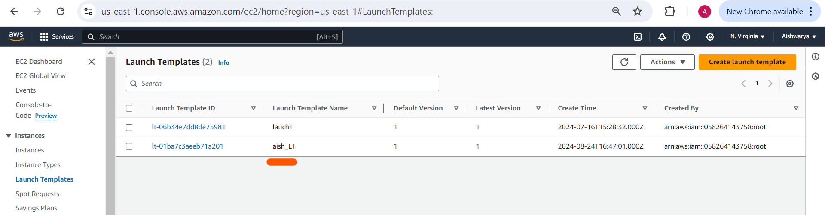

Now create load balancer and auto scaling group

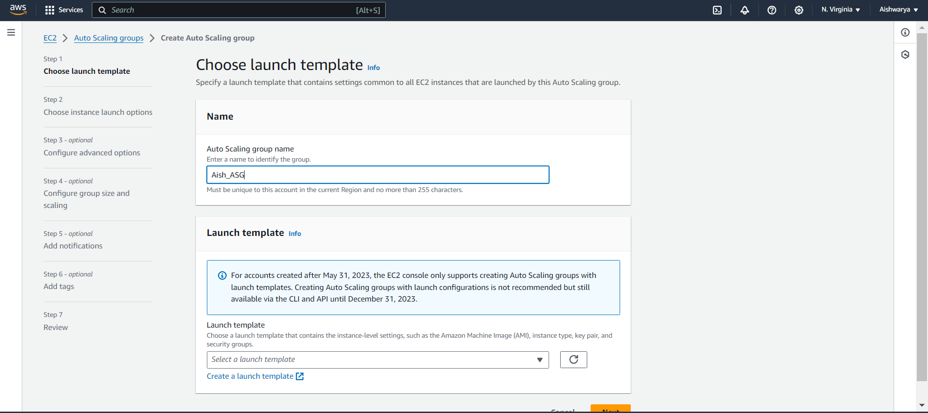

Select LT

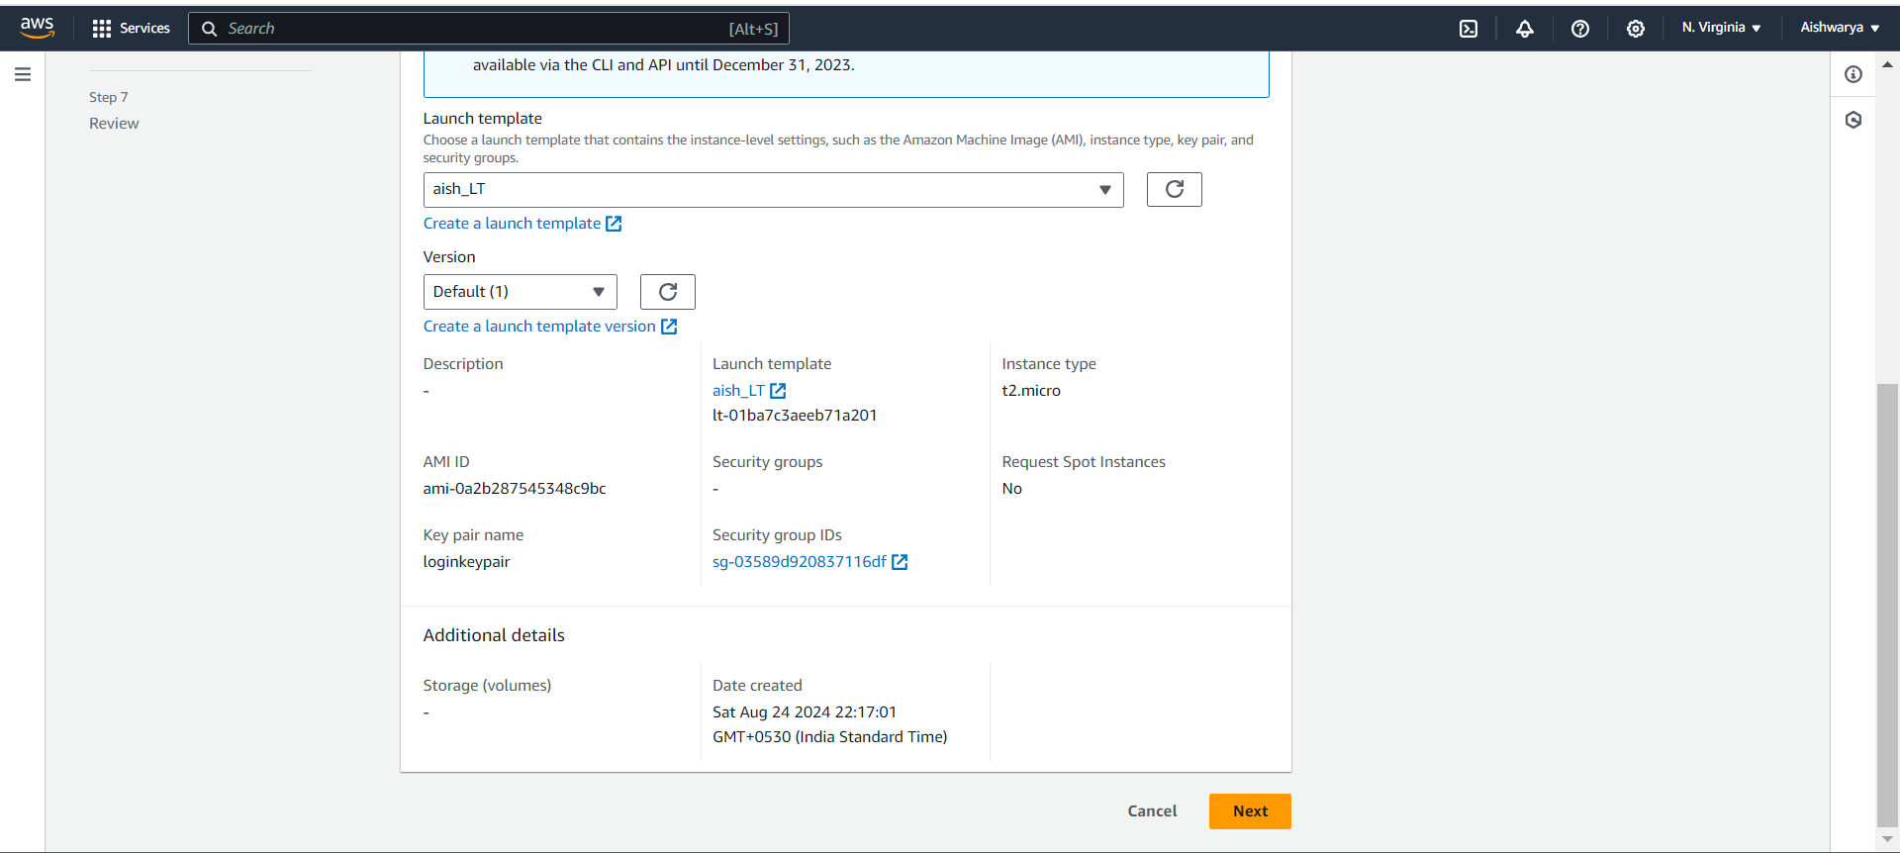

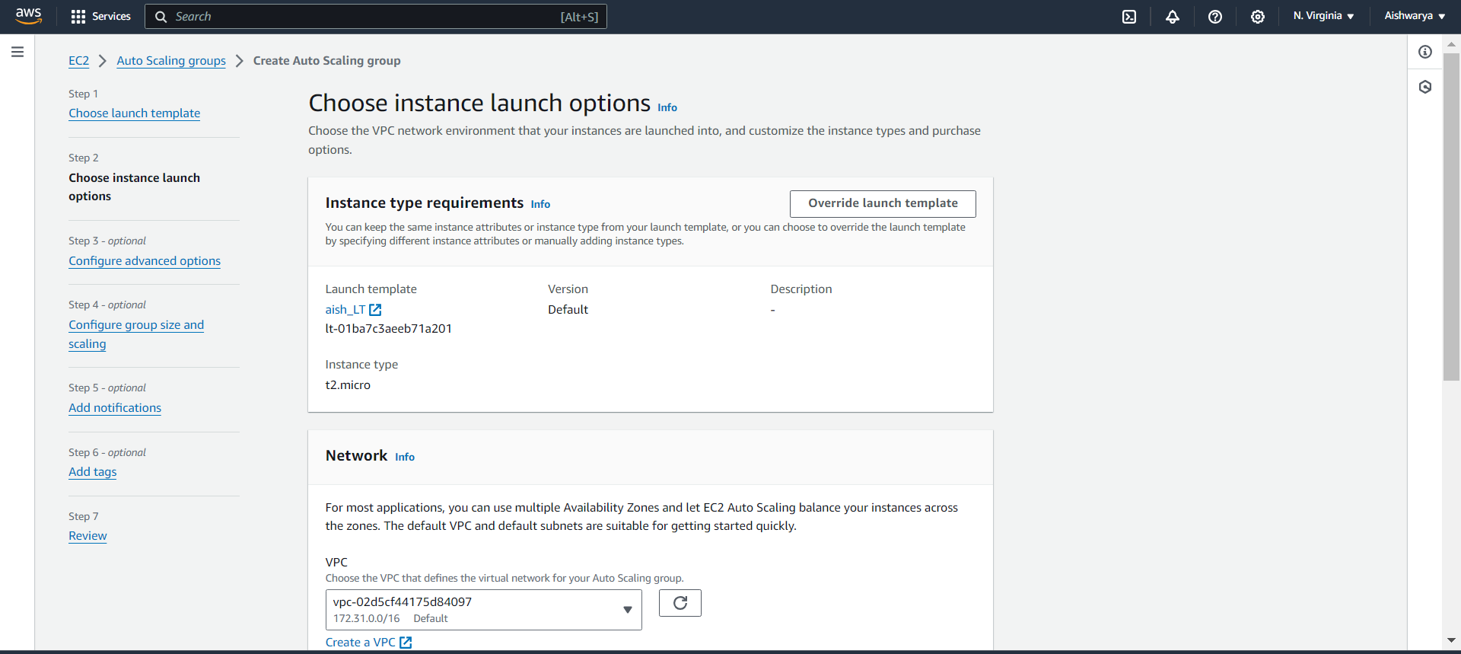

Choose AZ

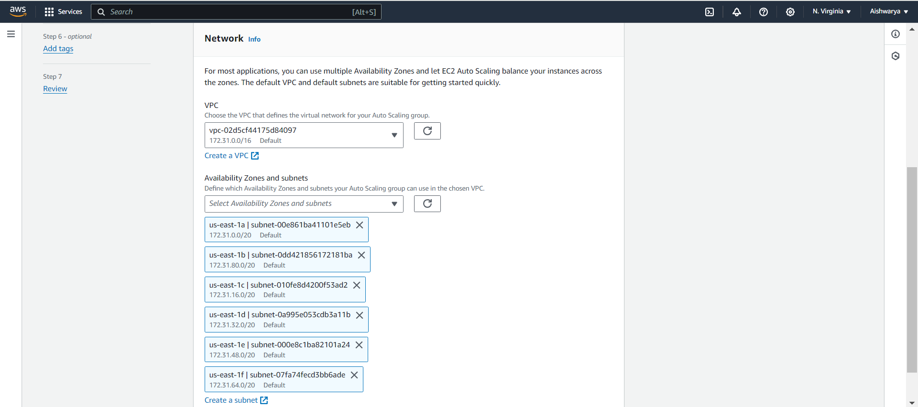

Create load balancer

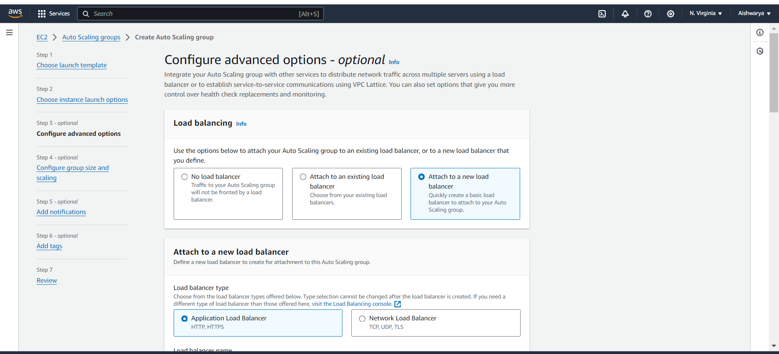

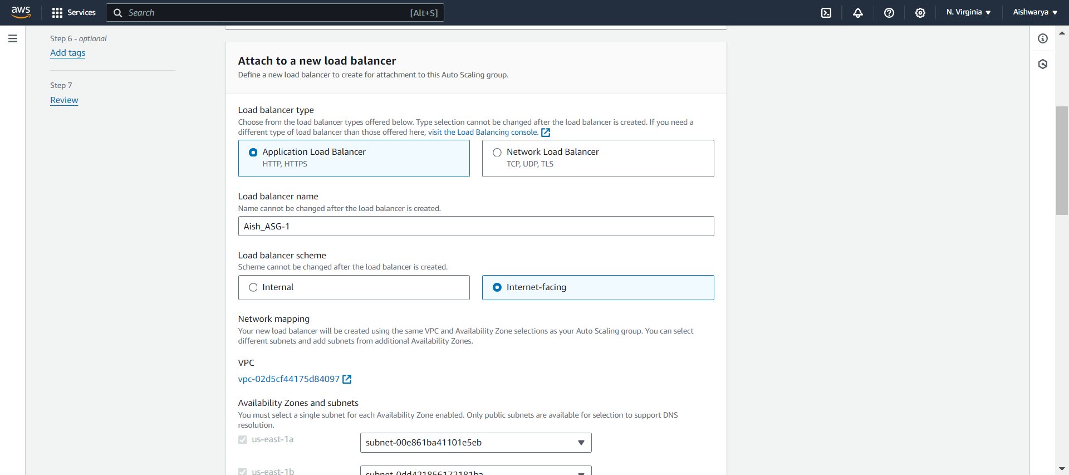

Create TG

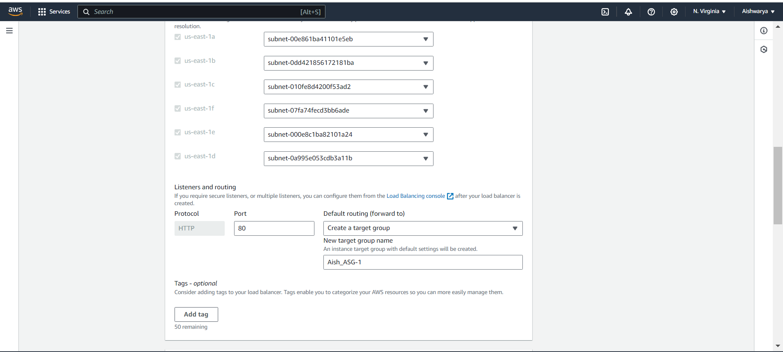

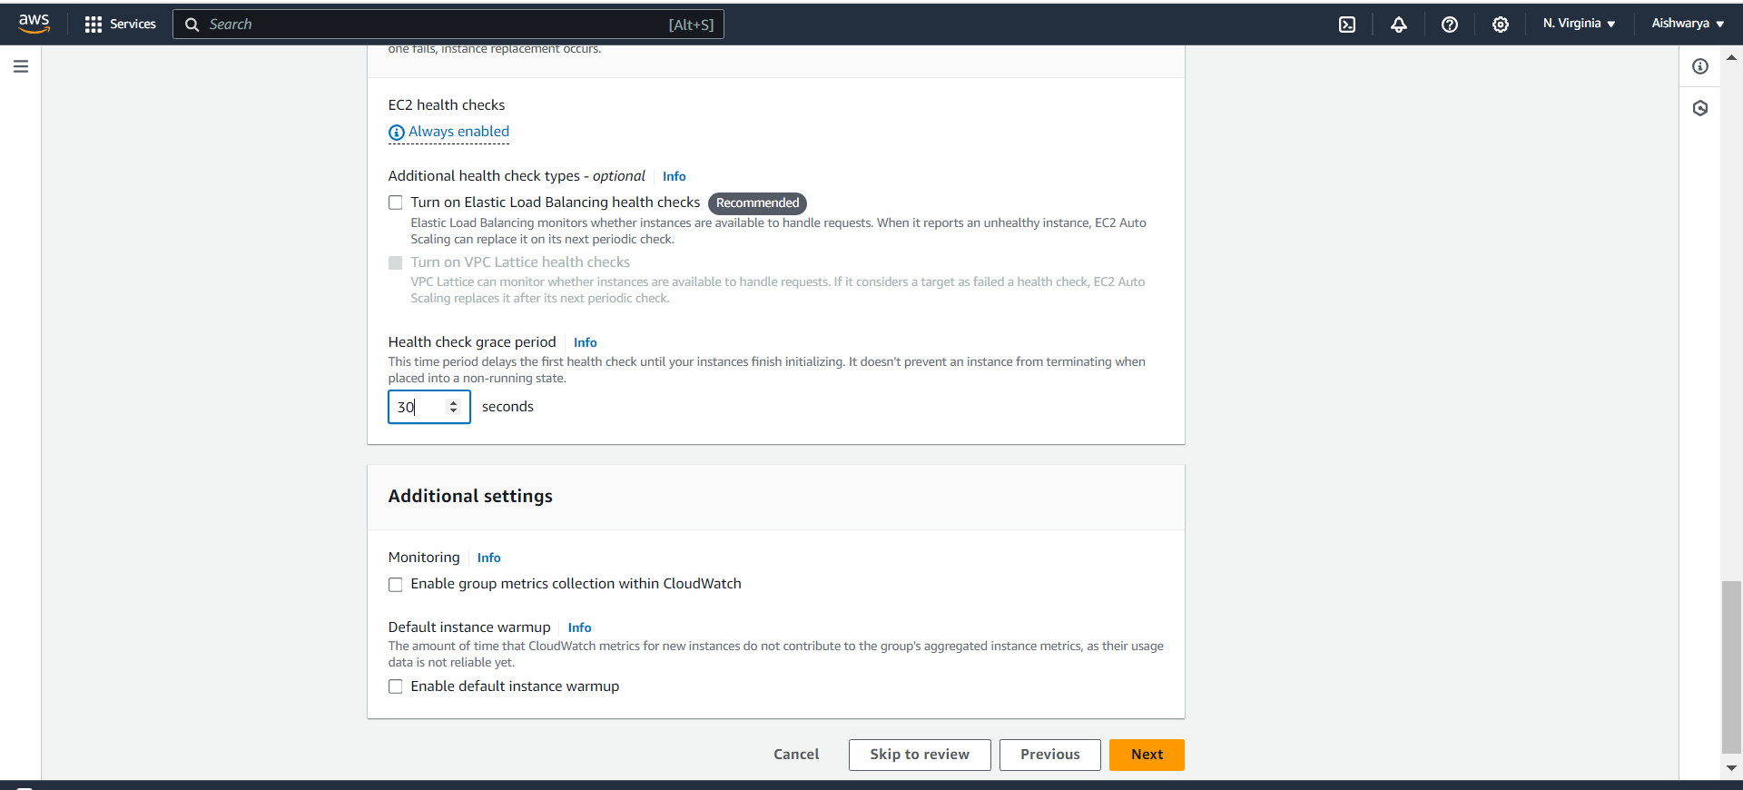

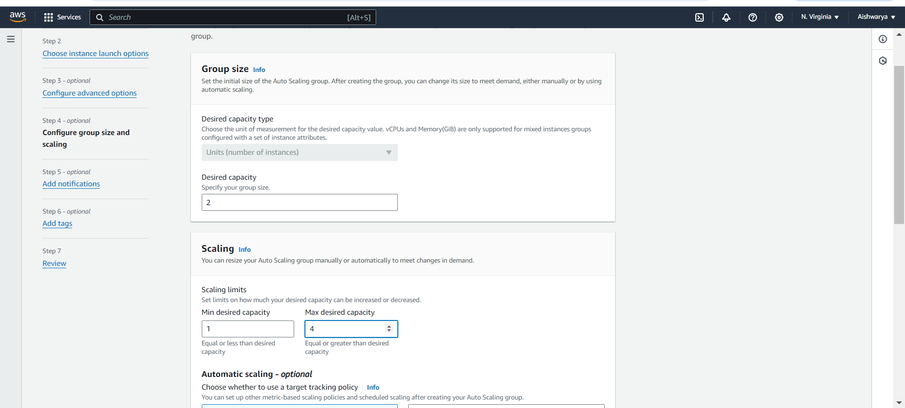

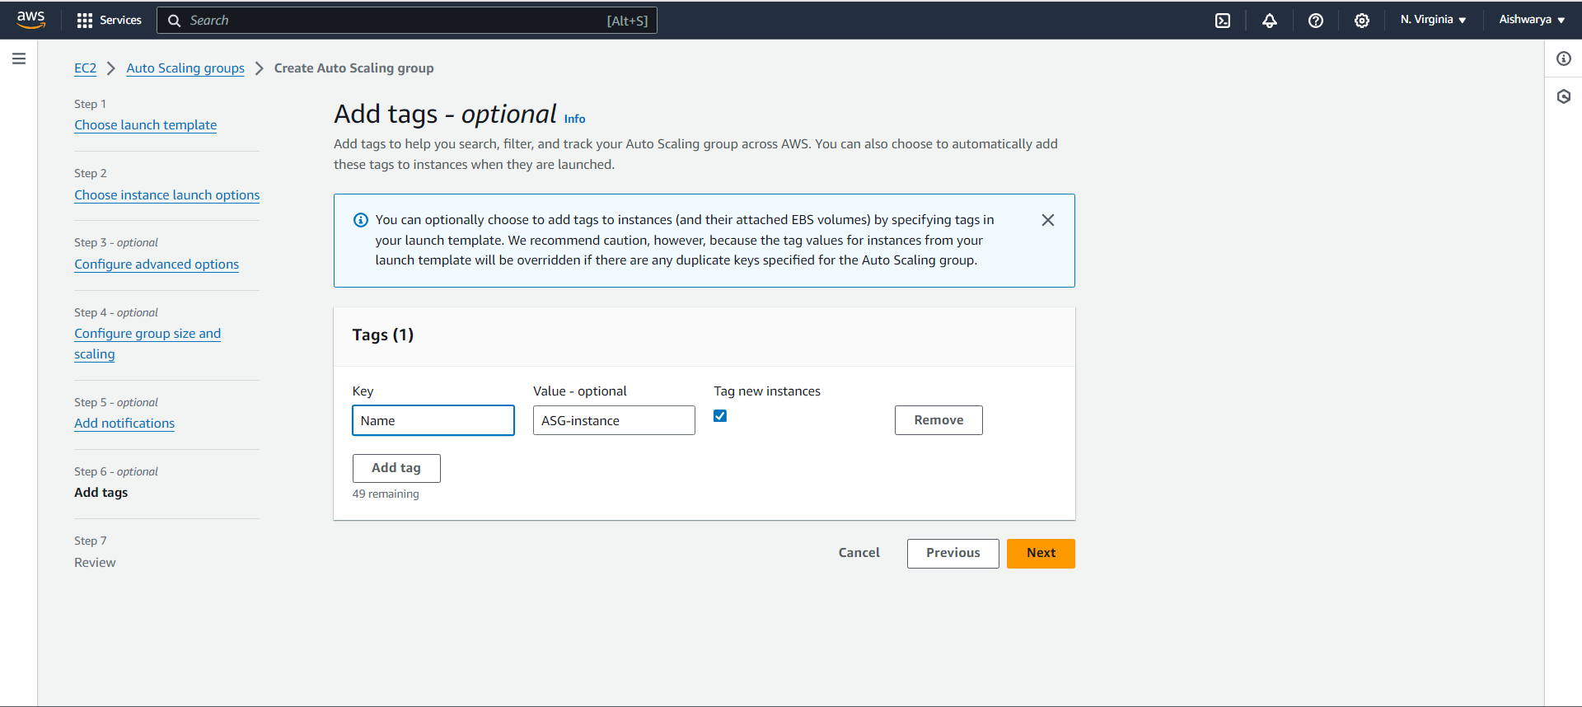

ASG

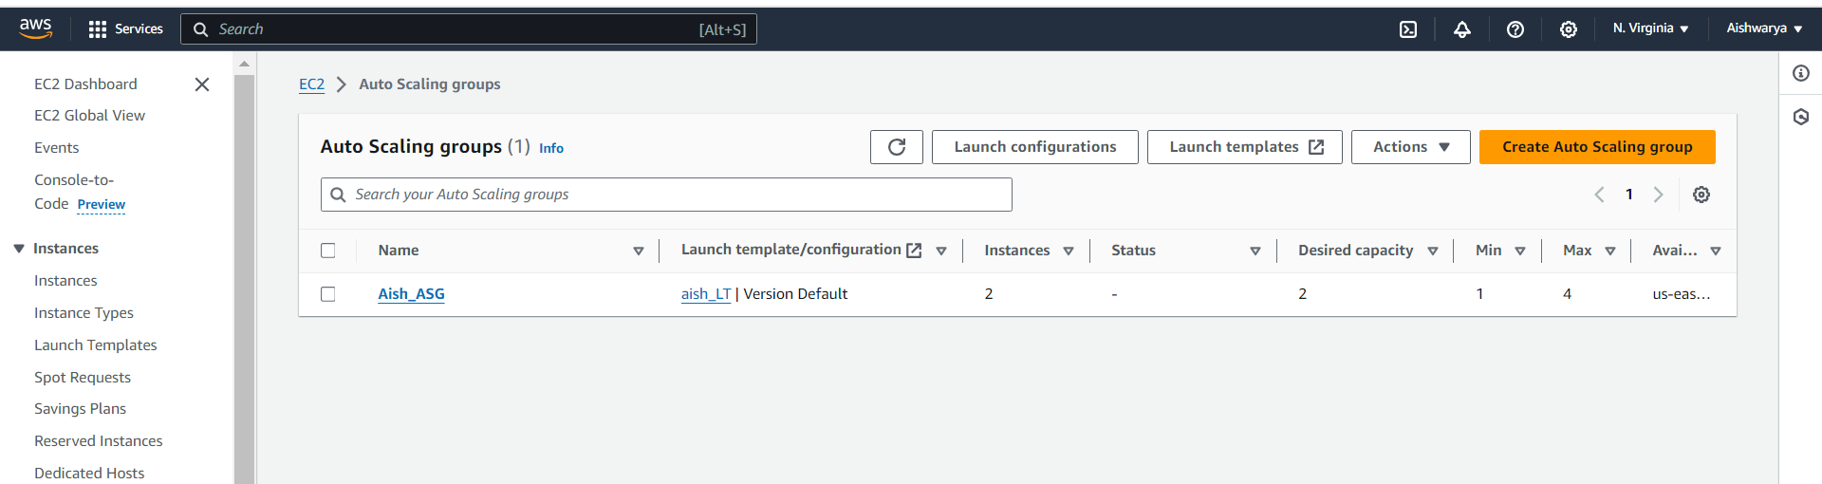

Load balancer

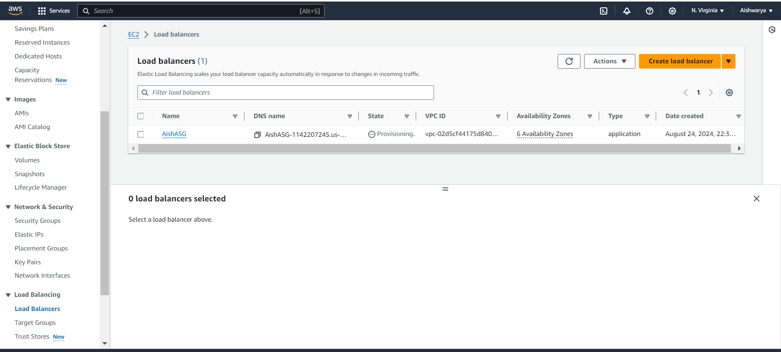

TG

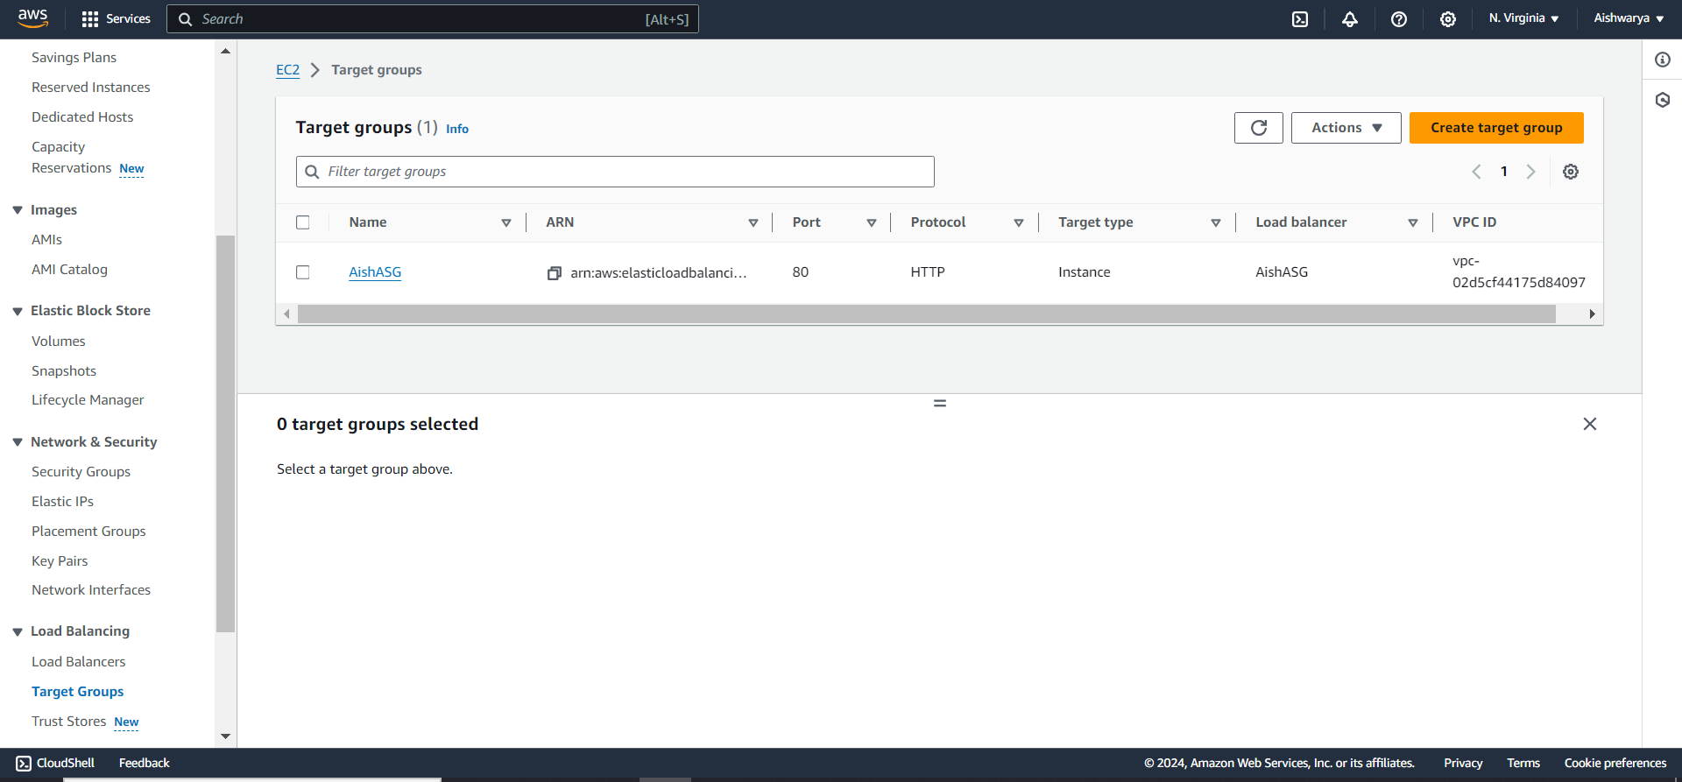

Instances

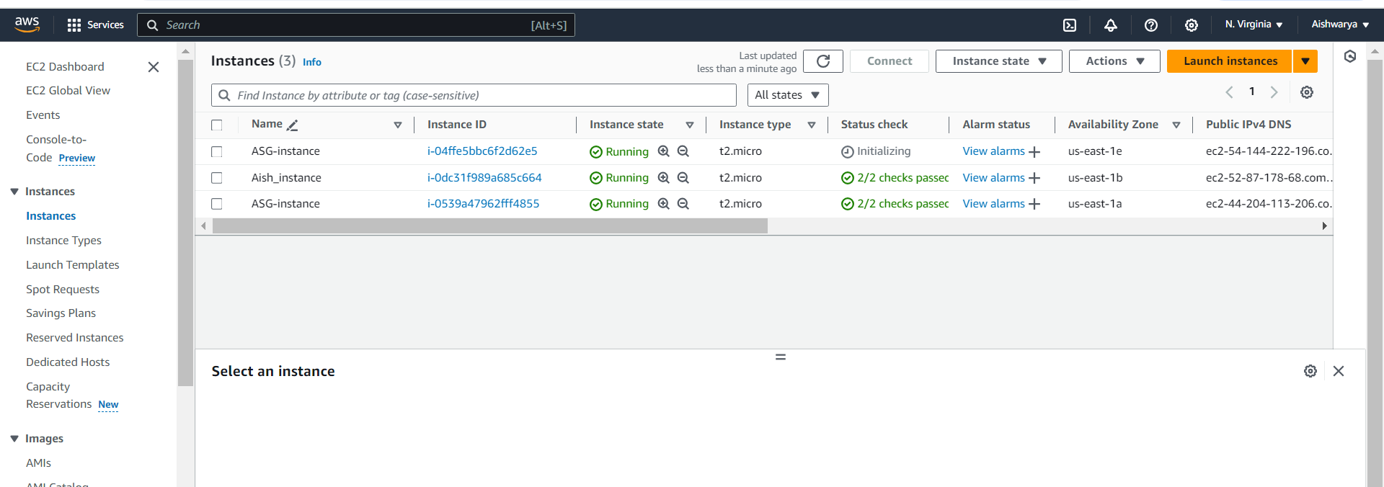

Check TG instances

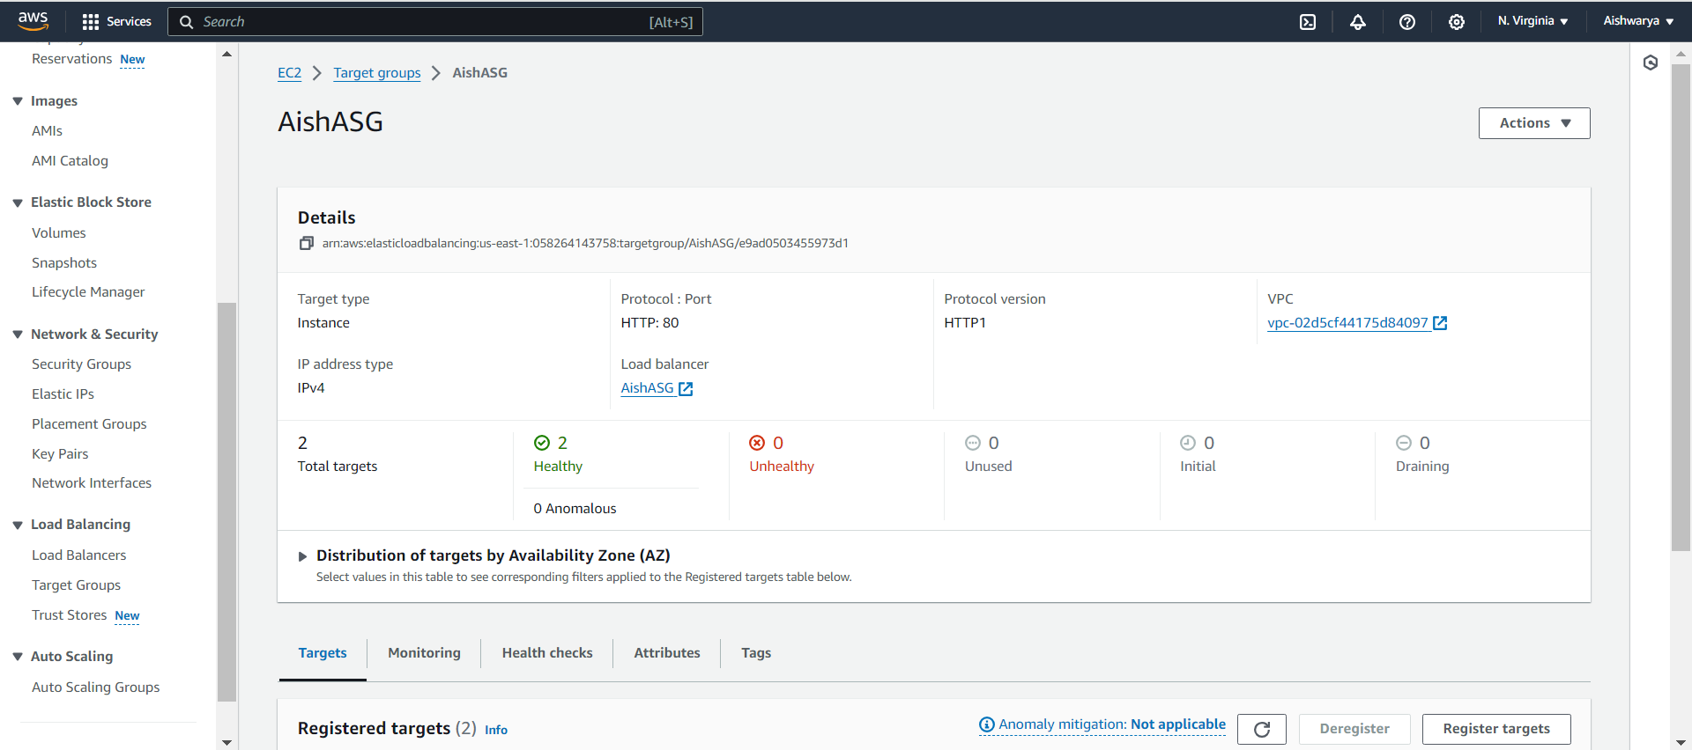

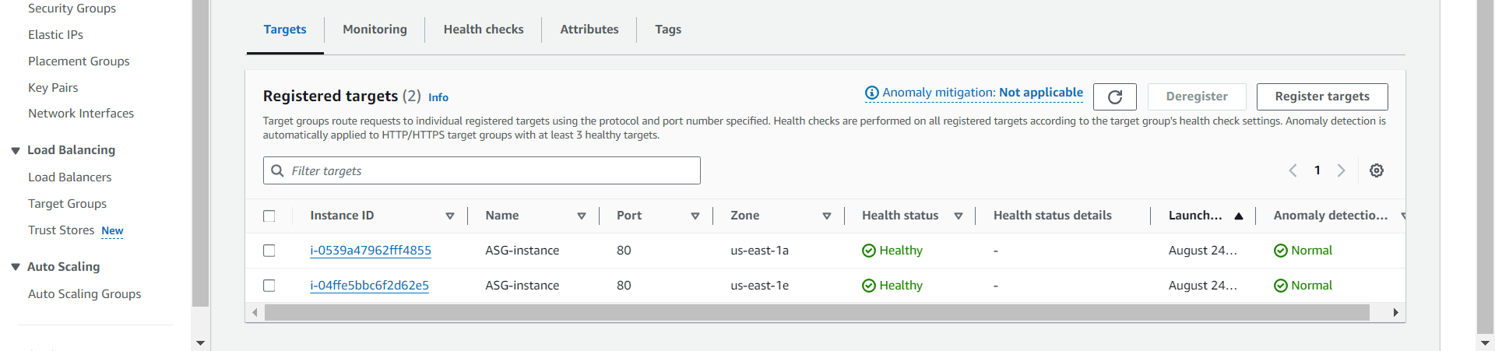

Take public Ip

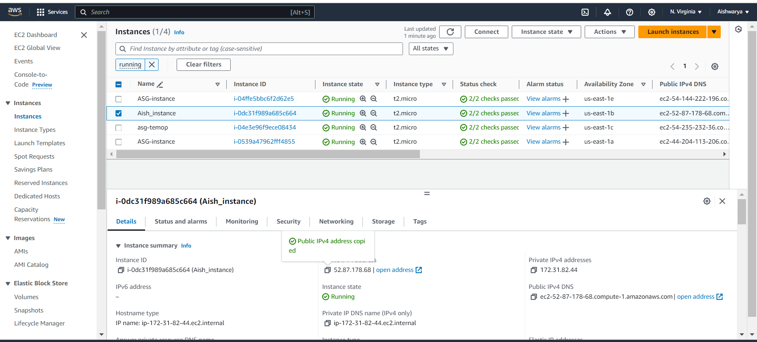

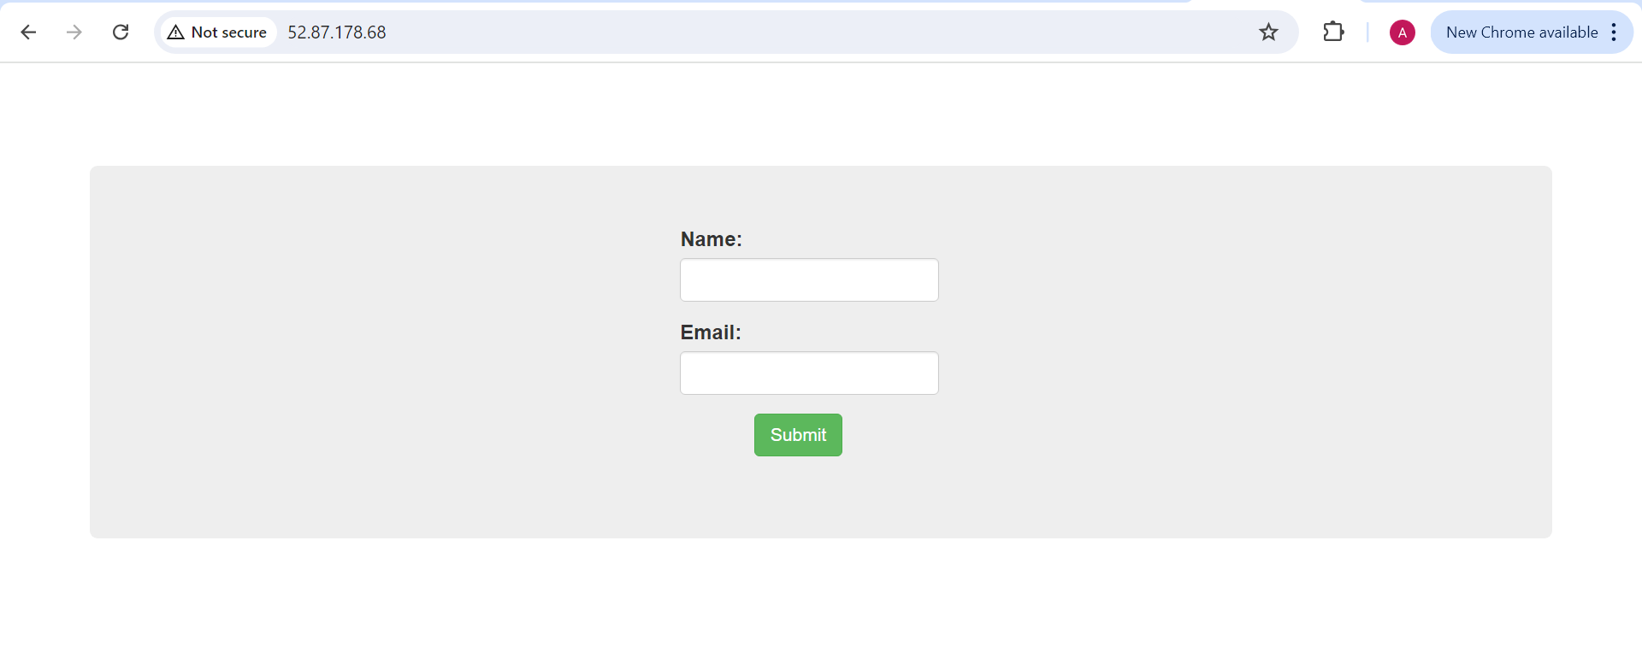

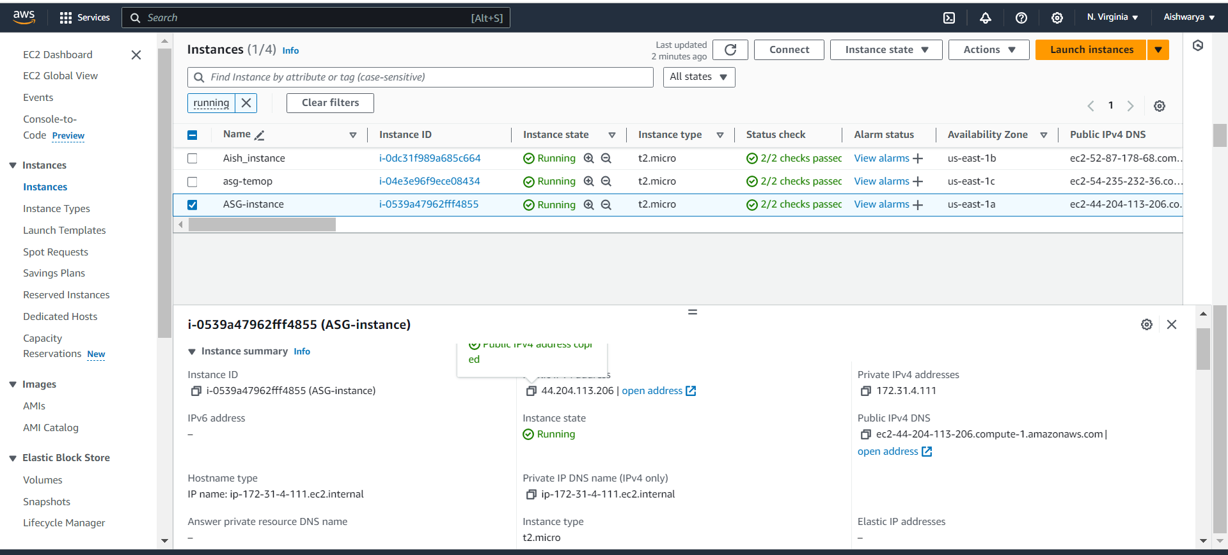

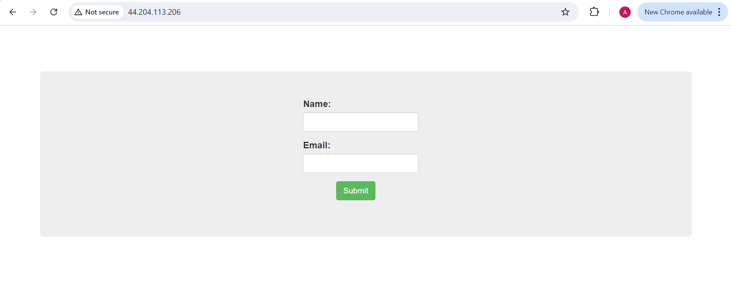

DNS

